Database Project – Group 3

**Student Id:** C03913555

**Student Names:** Utsav Bajracharya, Ranish Shrestha, Roshan Dhakal

**Submitted date:** 2/18/2019

**Table of Contents**

**Part1 – Company Overview and Product** 1

Company Name 1

Company Overview/Description 1

Products 1

Product Attributes 1

**Part2 – Customer Sales Invoice** 2

**Part3 – Entity Relationship Diagrams** 3

ER diagram 3

**Product:** 4

**Company:** 4

**Part3 – Entity Relationship Diagrams** 7

ER diagram 7

**Product:** 7

**Company:** 7

# **Part1 – Company Overview and Product**

## Company Name

Oasis Hardware

## Company Overview/Description

Oasis Hardware company

## Products

Oasis Hardware company provides a wide range of goods and equipment for building, house renovation, maintenance, and repair. Our goal is to offer top-notch hardware solutions to a variety of sectors and uses. The products we have are known for their quality and reliability. Here are some of the products offered by our company:

**Safety Gears department** – In this department, we store safety gear and equipment to prioritize worker safety. We have everything you need, such as safety helmets, gloves, dust masks, knee pads, work boots, ear protection, eye protection.

**Electrical Supply department** – Electrical tools, Extension cords, Switches, Circuit breakers, Wiring, Electrical outlets

**Paint and painting supplies** – Paint color, Paint brushes, Rollers, Drop cloths, Painter tape and Paint trays

## Product Attributes

|  |  |
| --- | --- |
| Product | |
| Primary Key (PK) | Product_ Id |
|  | **Name, Manufacturer**, Model, Brand, Type, Description, Size, Color, Weight, Height, Length, Width, Price, Release_Date, Ratings, **CreatedBy, CreatedOn, UpdatedOn, UpdatedBy** |
| Unique Key (UK) | **Serial_Number** |

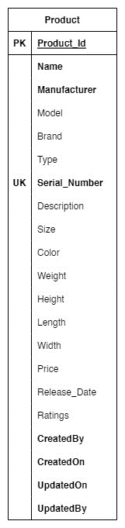

## **Part2 – Customer Sales Invoice**

# **Part3 – Entity Relationship Diagrams**

## ER diagram

## **Product:**

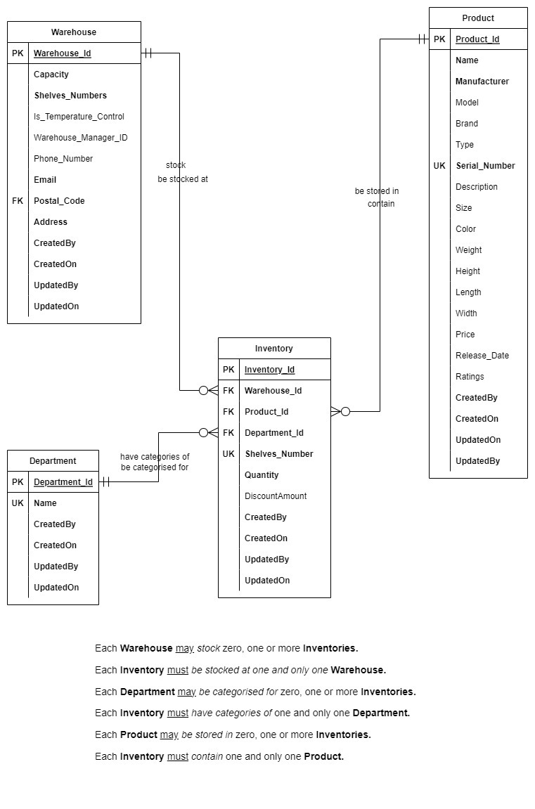

Figure 1 Product ER Diagram

### **Company:**

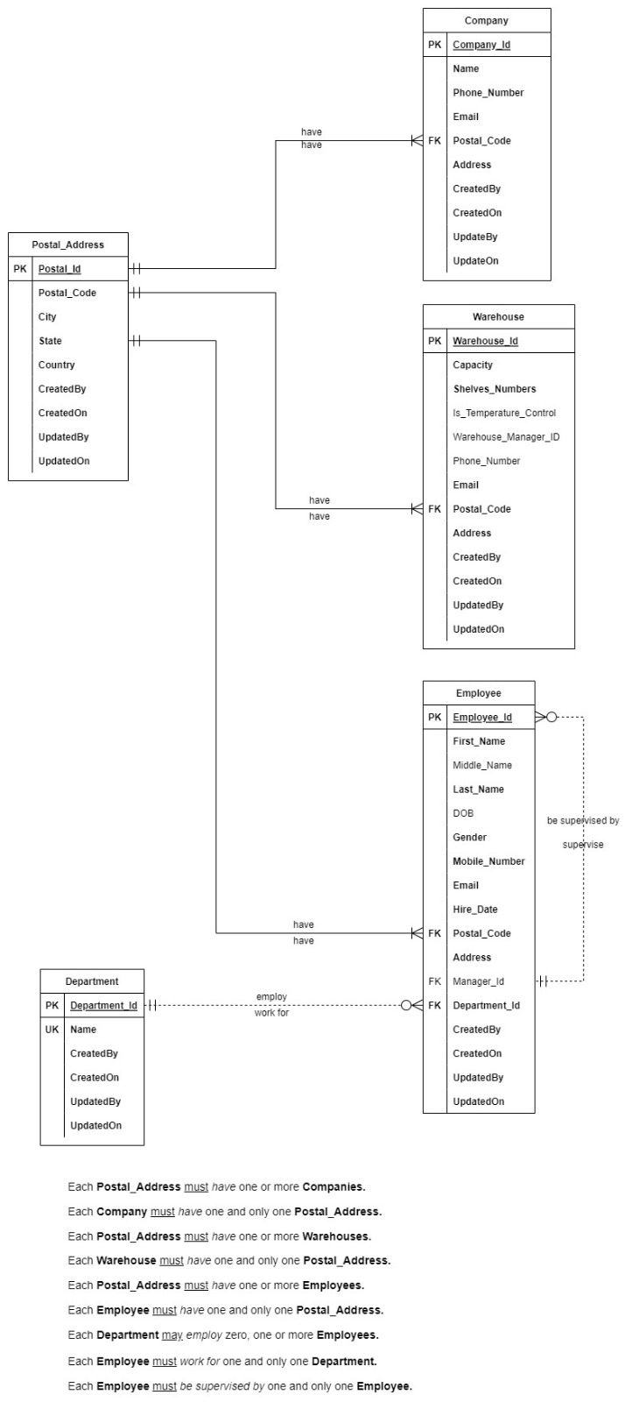

Figure 2 Company ER Diagram

**Customers:**

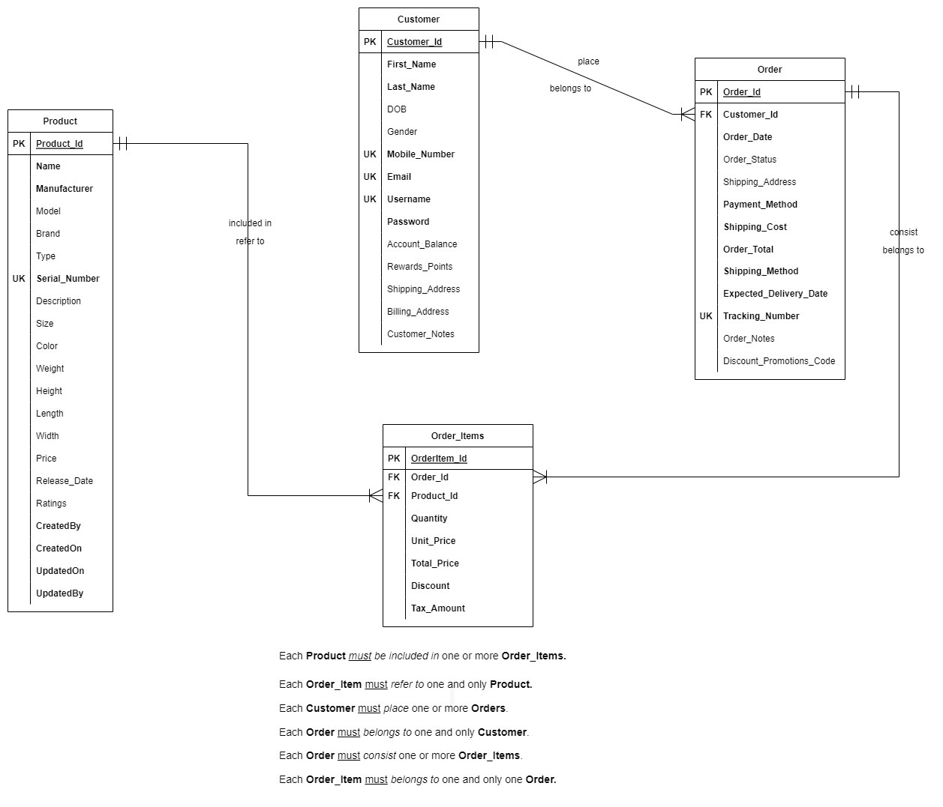

Figure 3 Customers ER Diagram

# **Part3 – Entity Relationship Diagrams**

## ER diagram

### **Product:**



Figure Product ER Diagram

### **Company:**



Figure Company ER Diagram

**Customers:**



Figure Customers ER Diagram